**Functional simulation of the RISC-V core Verilog netlist and testbench**

**1.Introduction of iverilog and gtkwave**:

Icarus Verilog (iVerilog) is a free, open-source Verilog simulator and synthesis tool, while GTKWave is a waveform viewer that displays simulation results, making them a powerful combination for Verilog development.

* What is Verilog netlist?

In the context of Verilog and digital design, a netlist is a textual description of the connectivity of a circuit, detailing the components, their interconnections, and optionally, their placement and routing, serving as a blueprint for simulation and physical implementation.

* Why test bench is necessary for RISC-V core?

A testbench is crucial for verifying RISC-V cores because it provides a controlled environment to simulate and test the core's functionality, ensuring it adheres to the RISC-V instruction set architecture (ISA) and performs as expected

**2. Installed iverilog and gtkwave for windows**

Command for simulation:

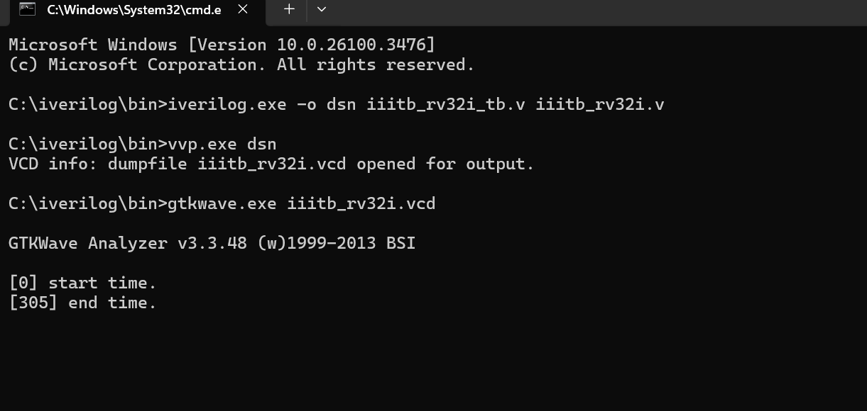

**3.Output**

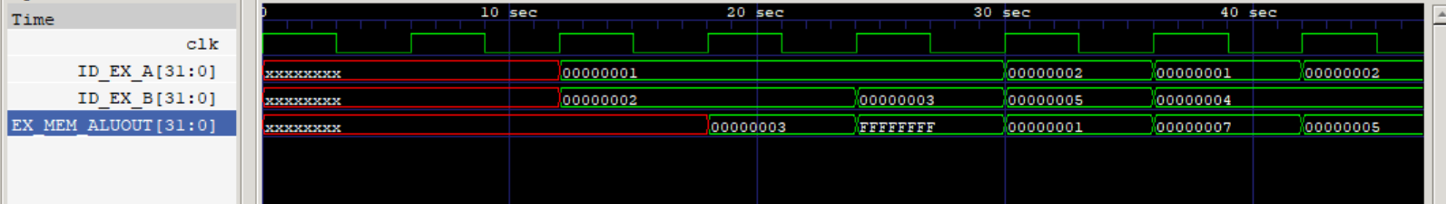

Values:

r1=00000001

r2=00000002

r3=00000003

r4=00000004

r5=00000005

Instructions and their outputs are shown below which can be verified through the output waveform:

* add r6,r1,r2

r6=00000003

* sub r7,r1,r2

r7=FFFFFFFF

* and r8,r1,r3

r8=00000001

* or r9,r2,r5

r9=00000007

* xor r10,r1,r4

r10=00000005

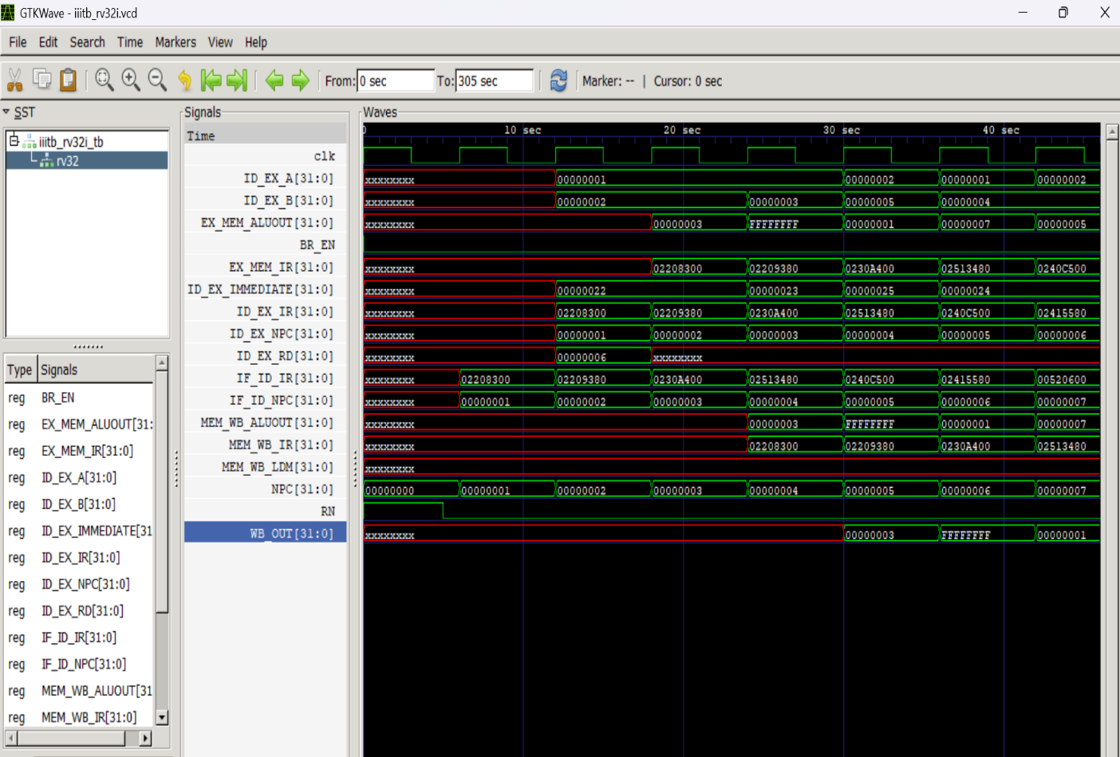

The above figure shows all the signals of Verilog netlist.